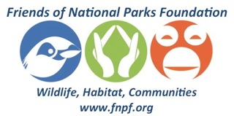
BWRC Volunteer application form

Full name
Address

Nationality
E-mail
Mobile

Do you have previous volunteering experiences? If yes, please describe.

Do you have previous experience working with animals? If yes, please describe.

Have you worked in tropical climates before?

What skills do you have which you think would benefit our project?

Preferred arrival date:

How long do you wish to volunteer for:

______ 1 week (USD120)
______ 2 weeks (USD220)
______ 3 weeks (USD300)

Please contact us for any additional information and send your application to: info@fnpf.org
Thank you for your application! We will get back to you as soon as possible.

